How to Record Mass Counts (Attendance) on the Mass Schedule

This document walks you thru the steps to enter Mass counts into each of the Masses on the schedule.

See also the article on how to enter Mass counts for Holy Days when they are not part of the regular Sunday obligation Holy Day Mass Counts - not included in Sunday obligation counts : Parish Support (freshdesk.com) .

To record Mass counts in Gabriel Software, the person entering the data must be a registered user of Gabriel, and have Service Manager security rights. The Church Administrator can assign the appropriate security rights.

Generally you will enter one Count for the entire Mass in the corresponding Mass on the Schedule. If you are tracking different areas of the church (like the Nave, the Gathering Space and the Parking Lot Radio Mass) you can make several Count entries into a Mass using the “Area” field for a “Comment section”.

The date of the Mass corresponds to the Day of the Week/Time of the Mass. The Saturday 4:30 Mass count would be entered into the Saturday 4:30 Mass from the schedule, the Sunday 10:00 am Mass count would be entered into the Sunday 10:00 am Mass from the schedule, and so on. The Saturday Masses should have a Saturday date for the count, and Sunday Masses should have a Sunday date for the count.

To record the Mass count for a Mass, click Scheduling > Service Maintenance
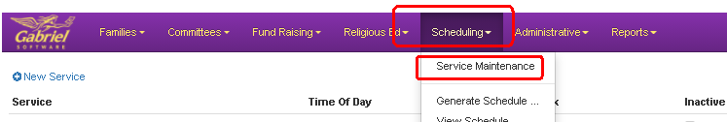
Select View on the right side of the Mass
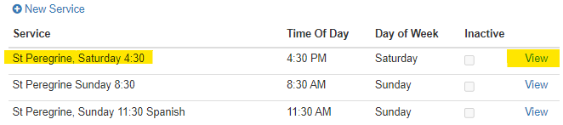

Click the Counts Tab, then Click +Add Service Attendance
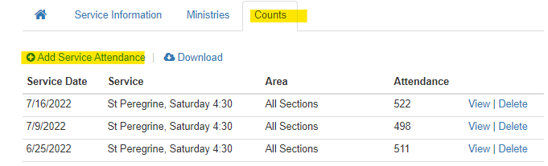

Select the Date the Mass was on (the date should be the same day of the week as the Mass day – Saturday Date for Saturday Mass) , add Comments on the Mass in Area", number of people that were counted, and Press Save.
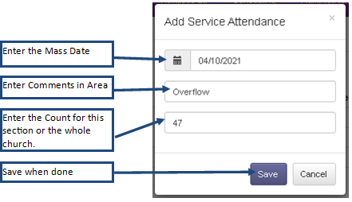

Here is an example of several Mass count entries.
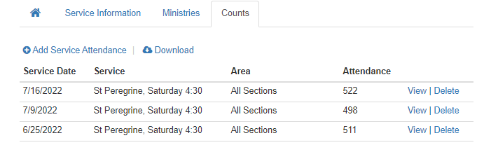
Click the House Icon to return to the schedule to enter Counts into the rest of the Masses

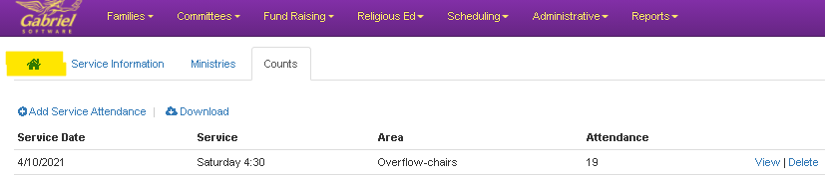
Choose the next Mass from the schedule and repeat the steps above until all Mass counts have been entered into their respective Mass.

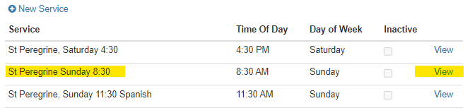

If you’d like to check your Mass count entries, you can pull a Report from the Report Library, Mass Count by Mass.

