How to Create and Add to the Mass Schedule

This Guide walks you thru creating a Mass schedule in Scheduling in preparation for entering Mass Counts Setting up holy day Masses is optional.

See also the article on how to enter Mass counts for Holy Days when they are not part of the regular Sunday obligation Holy Day Mass Counts - not included in Sunday obligation counts : Parish Support (freshdesk.com) .

To record Mass counts in Gabriel Software, the person entering the data must be a registered user of Gabriel, and have Service Manager security rights. The Church Administrator can assign the appropriate security rights.

To Set up Your Mass Schedule.
Click on Scheduling > Service Maintenance
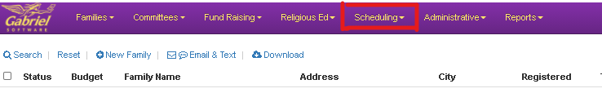

Click + New Service.
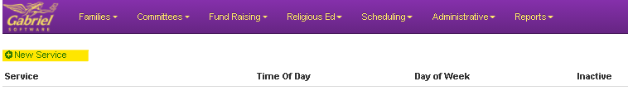
Enter the Location of the Mass, Day of the Week and Time. Click Save.
**Note that Masses will appear on the list in the order they are entered and cannot be re-sorted. You may want to enter your Saturday masses first followed by your Sunday masses. ** Gabriel Support can re-sort them – just send greenbay@gabrielsoft.com an email.

**At a Minimum, all parishes must have their weekend masses set up.**
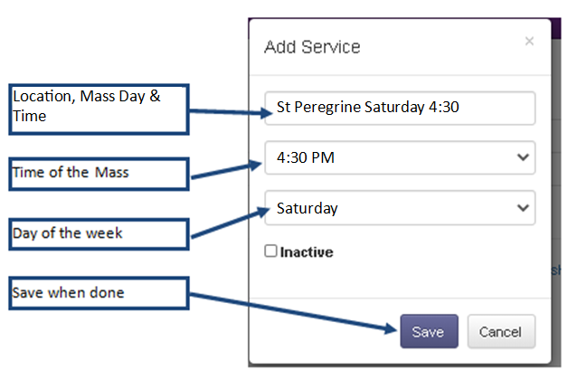

Repeat the Steps above for creating each Mass on your weekend scheduled.

Once complete, your Masses will be setup. From here on – you will enter your weekend counts into these Masses in your schedule. Each Mass count gets entered into it’s corresponding Mass time.

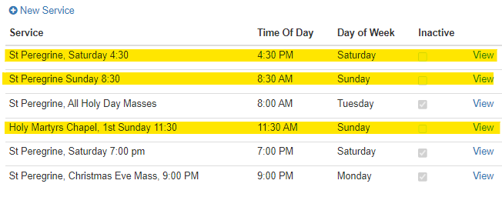

If you have Masses on your list that are no longer Active, mark them Inactive and Press Save.
Inactive Masses occur if you have alternating schedules such as the Door County Parishes. If a Mass becomes Active again, simply uncheck the Inactive box and Press Save.

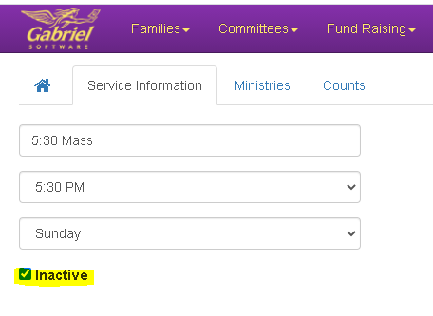
Once you have your Parish Mass Schedule set up, there’s no need to change it unless a Mass becomes inactive or a new Mass is added. Below is a Sample Mass Schedule:
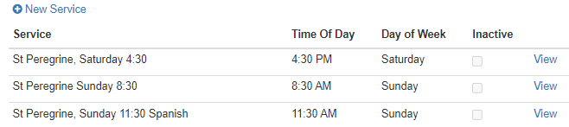

Generally you will enter one Count for the entire Mass in the corresponding Mass on the Schedule. If you are tracking different areas of the church (like the Nave, the Gathering Space and the Parking Lot Radio Mass) you can make several Count entries into a Mass using the “Area” field for a “Comment section”.

The date of the Mass corresponds to the Day of the Week/Time of the Mass. The Saturday 4:30 Mass count would be entered into the Saturday 4:30 Mass from the schedule, the Sunday 10:00 am Mass count would be entered into the Sunday 10:00 am Mass from the schedule, and so on. The Saturday Masses should have a Saturday date for the count, and Sunday Masses should have a Sunday date for the count.

If you’d like to check your Mass count entries, you can pull a Report from the Report Library, Mass Count by Mass.

