How to replace text with a graphic or an object
Word 2016 https://www.officetooltips.com/word_2016/tips/how_to_replace_text_with_a_graphic_or_an_object.html

Note: there are multiple tutorials and YouTube videos on doing this – just Google search “Find Replace Graphic”. Although the Find and Replace dialog box does not directly support replacing text with pictures or objects, you can efficiently perform this action using the Clipboard and the ^c wildcard.
This is a handy feature to insert a graphic, like a signature, after the closing line, or before the typed signature line. To perform this procedure, follow these steps:
1. Determine the text you want to replace like “sincerely,”
2. Copy the graphic or component you want to insert into the document onto your Clipboard. (click on the graphic and Ctrl+c or click Copy from the menu). This puts your graphic on the clipboard as the last item you copied.
3. From the Home ribbon, click Replace from the Editing box to get the Find/Replace box. (or press Ctrl+H to display the Replace box.
4. In the Find what box, type the placeholder text (such as “sincerely,”)
5. In the Replace with text box, enter ^c to indicate the last item copied to the Clipboard. To insert a paragraph space between the text and the graphic – add ^p before the ^c- (which means insert paragraph marker)
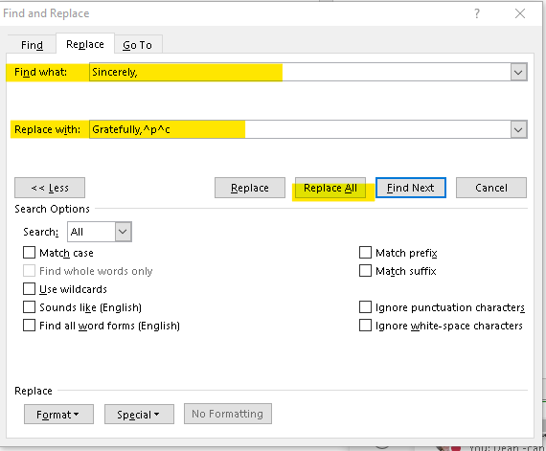
6. Click Find Next and then click Replace, or click Replace All.
Although the Find and Replace dialog box does not directly support replacing text with pictures or objects, you can efficiently perform this action using the Clipboard and the ^c wildcard.

There are other formats and choices you can make from the Special drop down list or the format drop down list. Open the drop down lists to check them out.

Replacing special characters
Word 2016 (https://www.officetooltips.com/word_2016/tips/replacing_special_characters.html
In addition to searching for and replacing text, you can search for and replace Word's special characters, such as paragraph and tab marks.
To find and replace special characters, follow these steps:
1. On the Home tab, in the Editing group, click Replace:
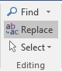
2. In the Find and Replace dialog box, click the More > > button:
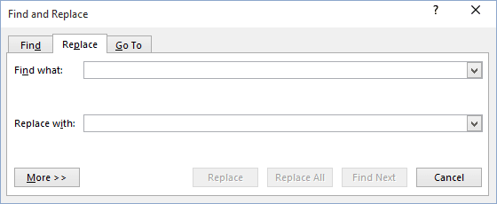
3. Click the Special button, and select the special character or item you want to find and any text for which you want to search.
4. Position the insertion point in the Replace With text box.
5. Click the Special button, and select the special character or item to add to the Replace With text box. You can add more than one special character to the text box, and you can also add text before or after a special character in the Replace With text box.
6. Make sure that the All option is selected in the Search list box. If you want to limit the search to text before or after the insertion point, choose the Up or Down option in the Search box.
7. Do one of the following:
- To confirm each replacement on a one-by-one basis, click Find Next. Then click Replace to replace the text or Find Next to skip to the next occurrence.
- To replace all occurrences of the search text without confirmation, click Replace All.
8. When the replace session for the entire document is complete, a dialog box informs you how many replacements were made. Click OK or press Enter to close the dialog box.
9. Click Close in the Find and Replace dialog box to end the session.

Characters in the Special Menu
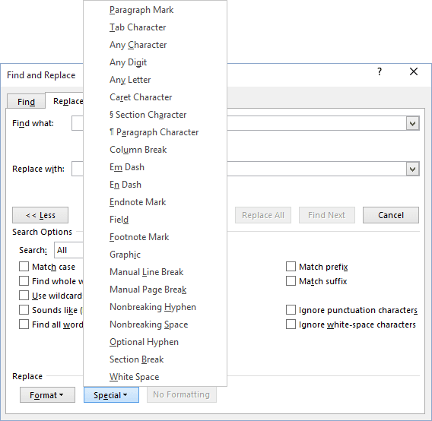

- ^p - Paragraph Mark
- ^t - Tab Character
- ^? - Any Character
- ^# - Any Digit
- ^$ - Any Letter
- ^^ - Caret Character
- ^u - Section Character
- ^v - Paragraph Character
- ^c - Clipboard Contents
- ^n - Column Break
- ^+ - Em Dash
- ^= - En Dash
- ^e - Endnote Mark
- ^d - Field
- ^& - Find What Text
- ^f - Footnote Mark
- ^g - Graphic
- ^l - Manual Line Break
- ^m - Manual Page Break
- ^~ - Nonbreaking Hyphen
- ^s - Nonbreaking Space
- ^- - Optional Hyphen
- ^b - Section Break
- ^w - White Space

