What is Power BI?
Created by: Abrunelle
Modified on: Mon, Oct 12, 2020 at 11:51 AM

Power BI is a business analytics service by Microsoft. It aims to provide interactive visualizations and business intelligence capabilities with an interface simple enough for end users to create their own reports and dashboards. The PowerBI Desktop software is offered FREE of charge.

Gabriel is providing PowerBI dashboards and reports to its parishes at no additional charge. Users need to download the PowerBI software to use the reports. Data contained in the file initially downloaded is from our Demo parish. Users will follow instructions on changing the data source and will login using their Gabriel user credentials.

Power BI Installation Instructions Print
Created by: Abrunelle
Modified on: Tue, Feb 23, 2021 at 9:23 AM

First:
Download the pbix file that you want to use from one of these articles:

Power BI PBIX File download - Single Parish
Power BI PBIX File Download - Multi Parish

The file will be placed in your downloads folder. You may want to move the file to your Desktop or a folder within your My Documents area. Remember where you put it so you can find it!

Second:
Click on the link below to download the PowerBI Desktop Software (FREE). Clicking the link will open the Microsoft Store in your browser. Click install. The download will take approximately ~5 minutes via a cable/high speed connection. Time will depend on your internet connection speed. Click the Launch button and Power BI will install.

Download PowerBI

When taken to the website - Click the Download Free Button

Third:
In Power BI, Fill out the registration form and press done. Click “Open Other reports” on the left hand side of the pop up. In next pop up window, click the folder in the left panel of the screen where you placed the pbix file in step 1 above.

In the right panel you will see a file “Gabriel Pastor Dashboard.pbix” (or “Gabriel Multi Parish Pastor Dashboard.pbix”), the file you downloaded in step 1 – click on the file and then press the open button.

Fourth:
The data you initially see in the report is from our Demo system. To look at your data you will need to do the steps below.
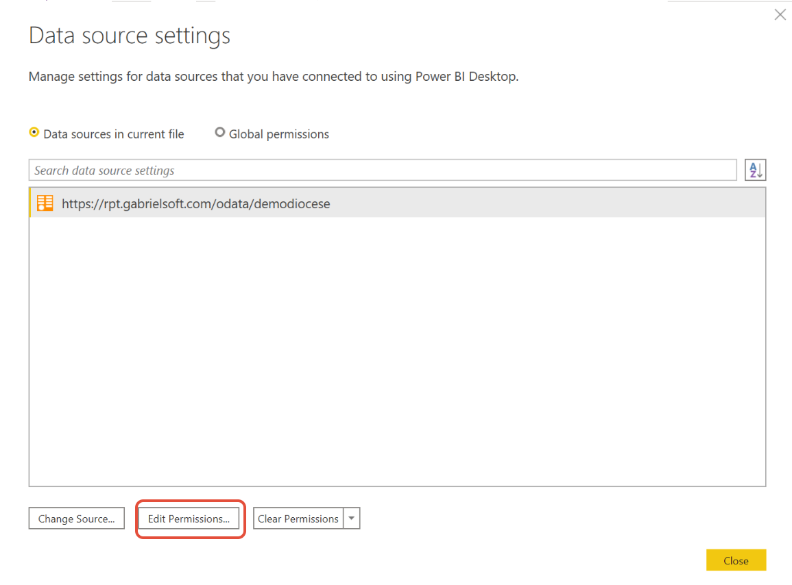

- Next click on edit permissions, and under credentials section click on the edit button.
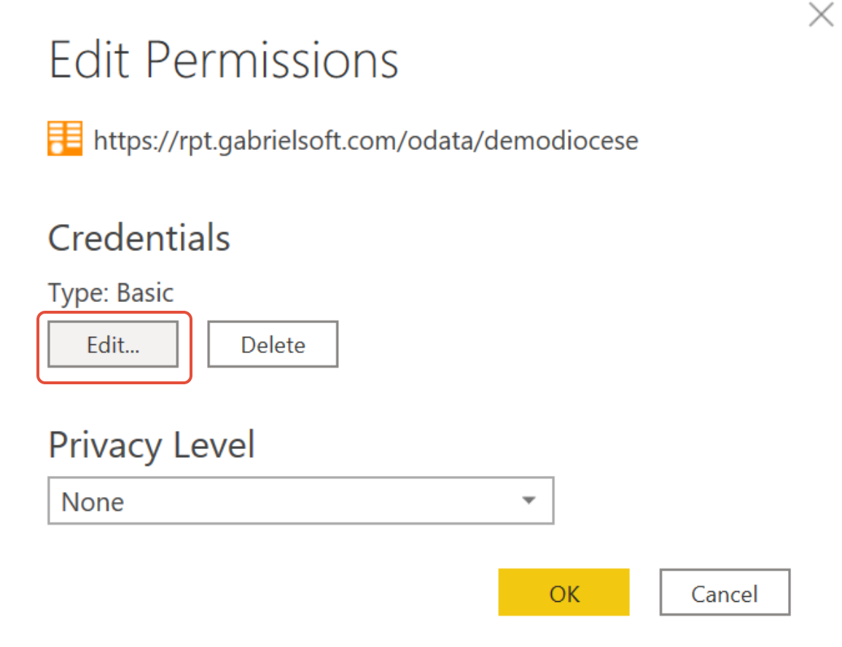
- With Basic highlighted on left enter your username and password, press save and then press ok and then press save
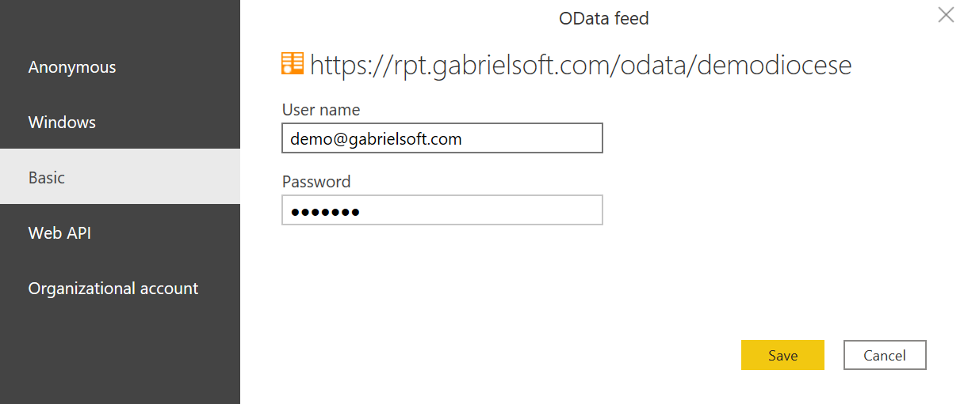
- A message should appear that says changes have been detected, press the apply changes button. OR if a message doesn't appear press the Refresh Button on the Home Ribbon as shown below

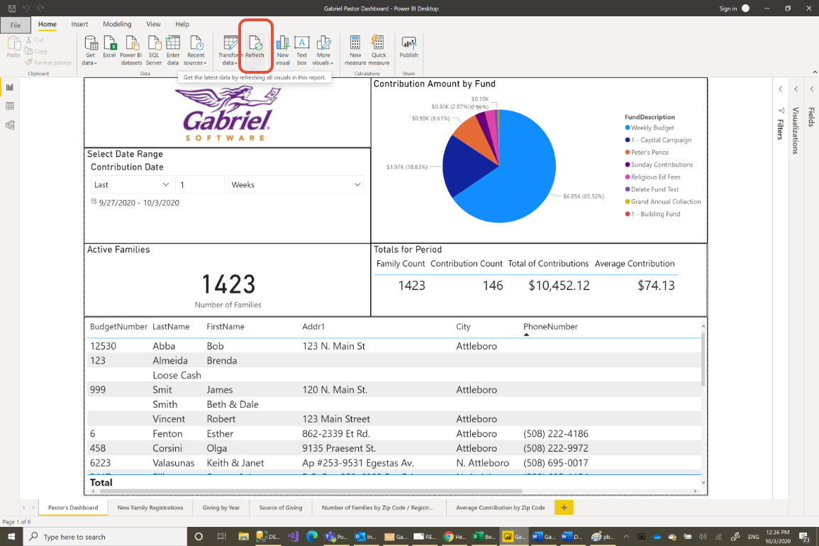
- Data from your parish will now start to download
  - NOTE: this could take between 5 and 10 minutes depending on your internet connection speed. Simply allow it to finish
- You now can interact with the reports with your data.
- When finished and closing the application be sure to click save to the question about saving your changes.

