How to Enter a Tuition Charge into Gabriel

- In the purple menu bar, click Fund Raising, then click Fund Maintenance.

- In Fund Maintenance, click 20/21 Religious Ed Tuition or Click on New Fund and create the year:

- Click on Active Pledges and then click New Pledge

- In the Family Name box, begin to type the students Last Name, and a dropdown box will appear with options. Select the family you want to enter tuition for. The Total Tuition Amount should go in the Pledge Amount Field. Note, this should reflect the total amount of tuition due including all kids in the program. If they have two kids, like in the example below, add the tuition totals together and put that amount in the Pledge Amount Field. Make a note below with the specific tuition amounts for each child.

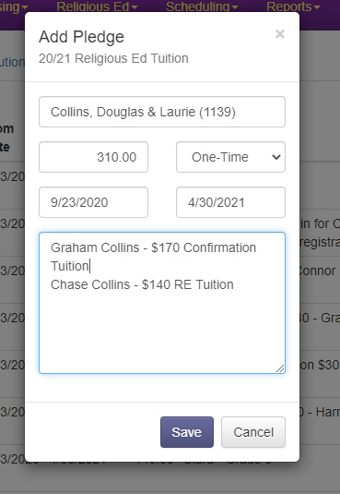

- Click Save and now you’re done!

