Do Not Send Mail to Parishioner:

Gabriel does not have a box to check "Do Not Mail". A workaround would be to go to Family Search and open their family record and click on the Mailing Address Tab and fill out as below. You can set the date fields and check recurring or you could use the date fields for a specific time span. For example, the family does not want to receive mail over the summer. It will print a label without any address and still maintain the family address information in the Family Record. If at any time they want to receive mail again simply go and uncheck the box in Mailing Address Tab.

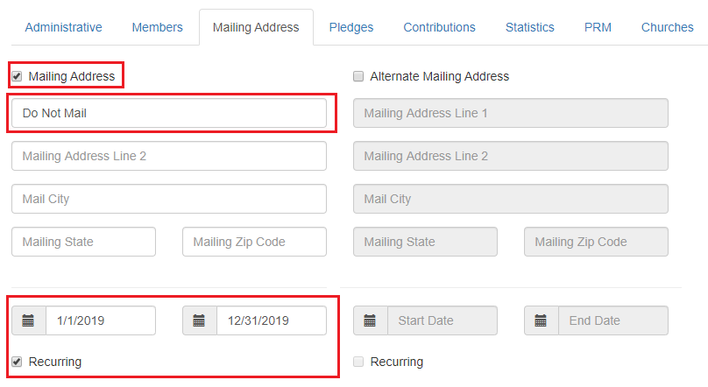

When you print any letters and/or labels the address field will print like the example below. As you are stuffing your letters or putting labels on your envelopes you would simply not use the label or pull the letter before folding and stuffing into the envelope.

