Envelope Vendor - Church Budget Integration

Contact Gabriel's help desk at support@gabrielsoft.com and mention that you use Church Budget envelopes and need to setup the integration for auto-ordering offertory envelopes.

Church Budget automatically pulls the data for creating Envelopes they look at three fields highlighted in Yellow below
- Family Status is Active,
- Inactive Budget Box is NOT checked
- Has Envelopes Box IS checked

All three of these criteria must be met for Church Budget to pull the family to receive envelopes.
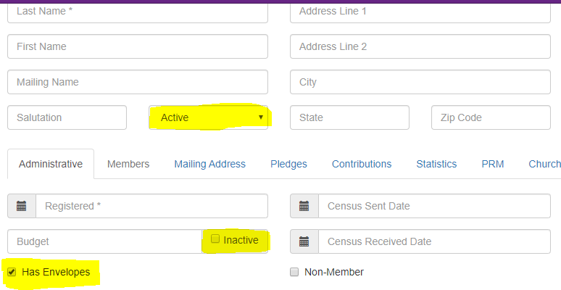

First line on the Envelope - The integration will first look for something in the Mailing Name field. If it has data in it, the value in the Mailing Name field will be the first line on the envelope. If there is nothing in the Mailing Name field then it will default to Salutation + First + Last Name for first line on the envelope.

