Zero Givers Report
- Go to Fund Raising and select the fund to be reported on (report only works for one fund at a time):
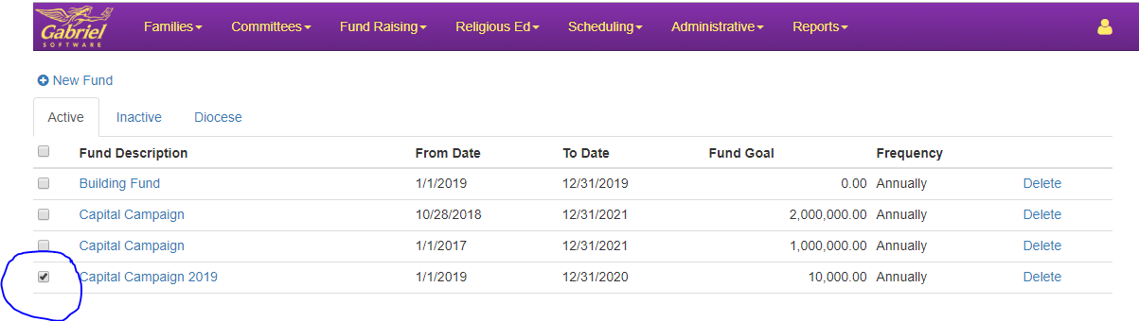

- Under Reports, select Mailing Labels:
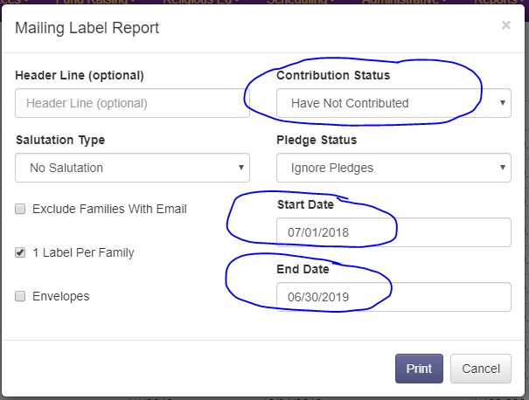

- When you press Print, a .pdf is created with the Family Name, Street Address, City, State and Zip Code ready to be printed off on label stock.

