Adding a Pledge to a Family:

- Go to Fund Raising and select a fund or create a new Fund:
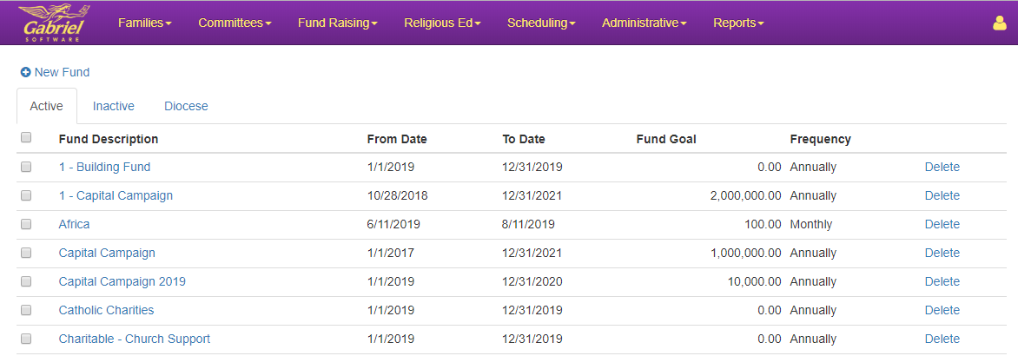

- Go to the Active Pledges Tab:
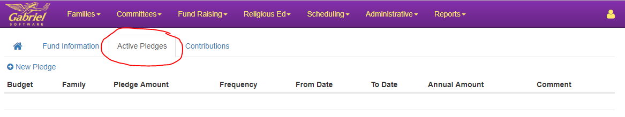

- Select a family:
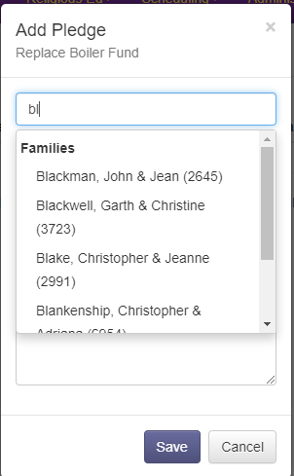

- Complete the Pledge Information and Save:
