How email works in Gabriel Software:
- Sending email from the Parish:
When email is sent out of Gabriel, the email will come from the email address that is found under Administrative and then Church Maintenance.
When an email is sent to the Religious Education group, the email will come from the email address under the Religious Education email. If no Religious Education email is specified, the email will come from the General Information email address.
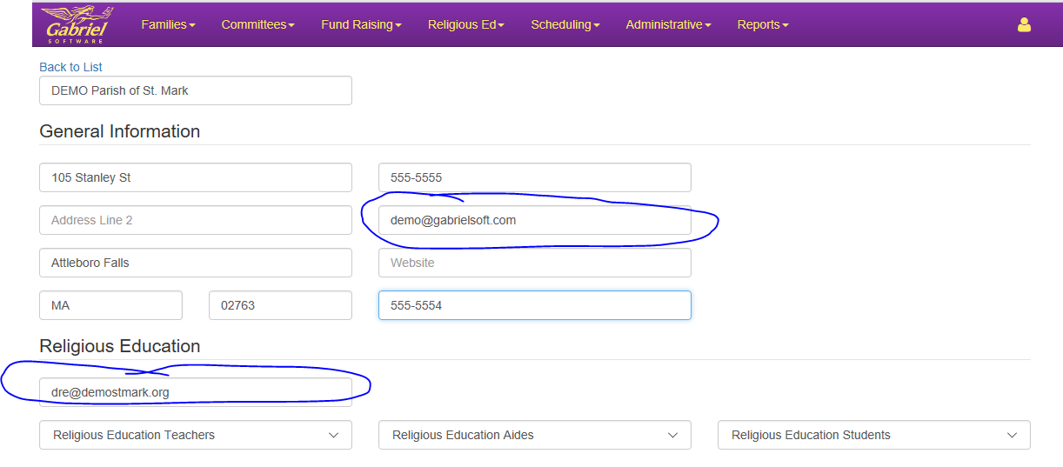

Future Enhancement: From Email address will be the email address of the person signed in to Gabriel.

- Email address used for Committee:
Gabriel checks the Contact by Email box on the Member record. If the box is checked the Committee module will include the email from the Member. If the box is not checked, Gabriel will use the family email address, if available.

- Email address used for Religious Education:
Gabriel will always use the Family Emil Address. Gabriel will never use the email on a member record.

