Envelope numbers to the Printer:

- Do a Search to narrow the scope down to parishioners with Envelope Numbers. This search was for Active parishioners:

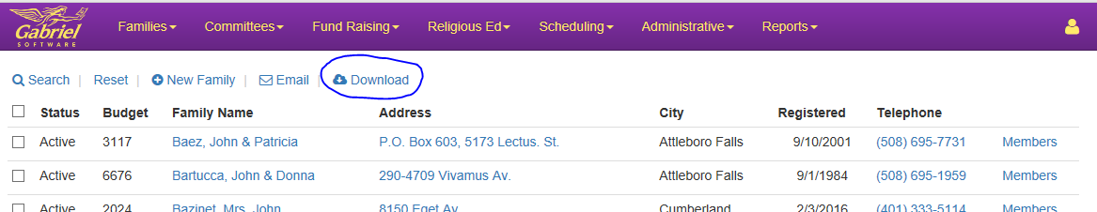

- Click on the Download Button and create a csv file:
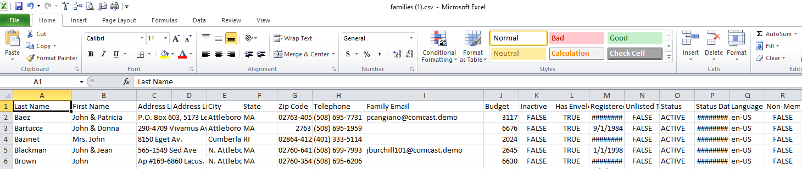

- Eliminate the fields that the printer does not need:
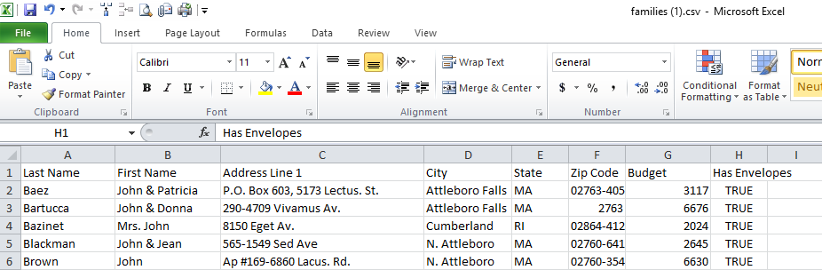

- Sort the spreadsheet by Has Envelopes (True or False):
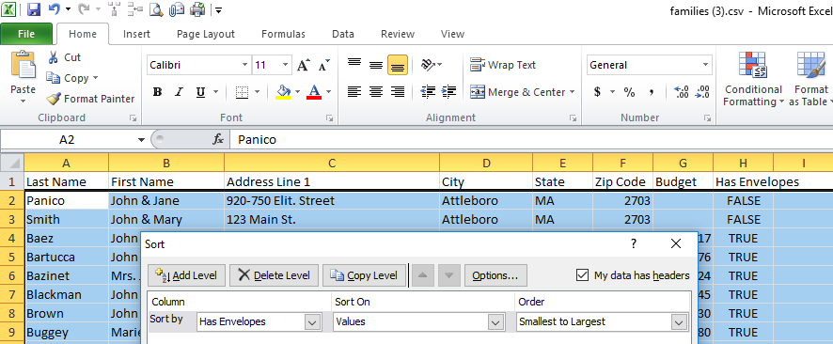
- Delete the parishioners that have False:
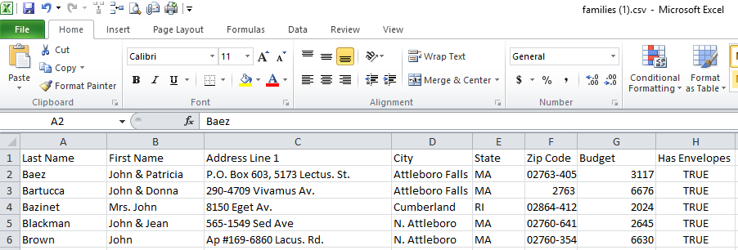
- Eliminate the column Has Envelopes:
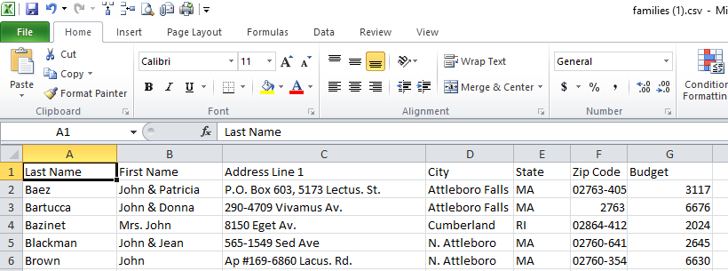
Your Excel spreadsheet is ready to email to the Printer.

